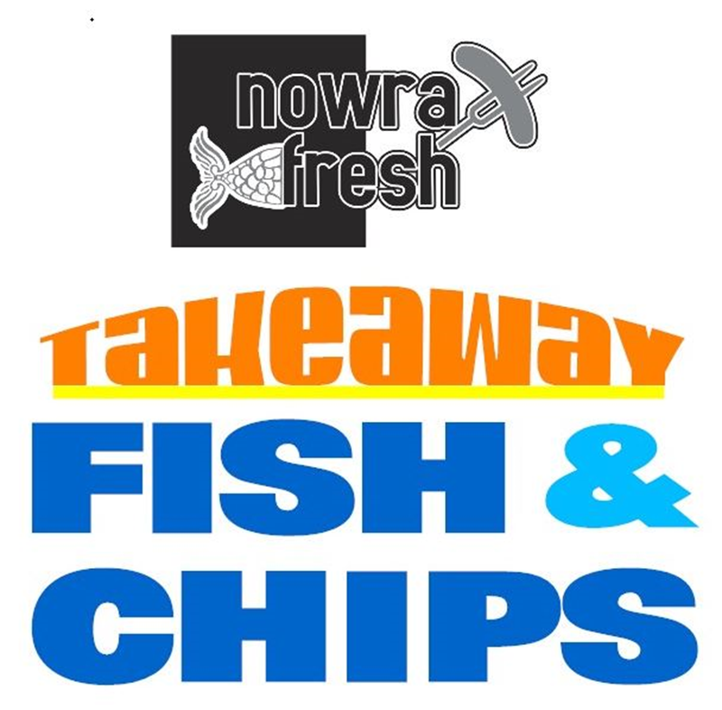

**PHONE: 02 4429 1999**

**CORNER MOSS STREET & PRINCES HIGHWAY**

**TRADING HOURS**

**MONDAY & TUESDAY: CLOSED**

**WEDNESDAY & THURSDAY: 11AM - 3PM**

**FRIDAY & SATURDAY: 11AM - 7PM**

**SUNDAY: 11AM - 3PM**

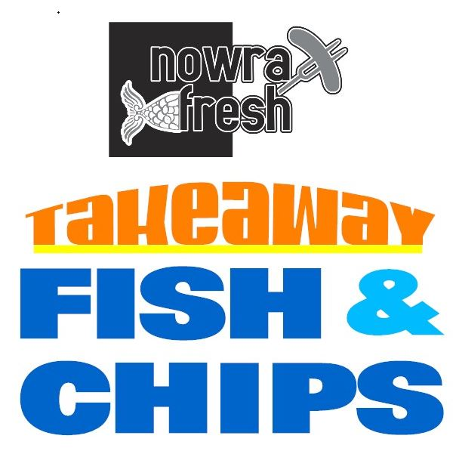

**PHONE: 02 4429 1999**

**CORNER MOSS STREET & PRINCES HIGHWAY**

**TRADING HOURS**

**MONDAY & TUESDAY: CLOSED**

**WEDNESDAY & THURSDAY: 11AM - 3PM**

**FRIDAY & SATURDAY: 11AM - 7PM**

**SUNDAY: 11AM - 3PM**



**ADD**

**SIDE OF CHIPS $2.50**

**On the Grill**

* SALMON/TROUT $19.90
* BARRAMUNDI $15.90

**SIDES**

* POTATO SCALLOP $2.00
* BATTERED SAV $3.50
* CHICKO ROLL $4.00
* SPRING ROLL $4.00
* CRUMBED CHICKEN

TENDERLOIN $2.50

* CRUMBED CHICKEN

SCHNITZEL $10.00

* GARDEN SALAD
* SMALL $4.50
* LARGE $8.00

**DRINKS**

* 600ML BOTTLE $4.90
* 375ML CAN $2.80
* 500ML FLAVOURED MILK $4.20
* 500ML ICED COFFEE $4.20
* 600ML WATER $3.00

**CHIPS**

* SMALL $5.50
* MEDIUM $7.50
* LARGE $9.50

**CATCH OF THE DAY**

* N.Z. HOKI $11.50
* LOCAL FLATHEAD $15.50
* LOCAL BLACKFISH $13.50
* LOCAL FLAKE $12.50
* FISH COCKTAILS
* CRUMBED $2.50
* BATTERED $2.50
* CRUMBED CALAMARI $1.20
* SEAFOOD STICKS $2.00
* PRAWN CUTLETS $2.50
* SALT & PEPPER SQUID $1.50
* FISH CAKES $3.50

**SAUCES**

* TARTARE
* SMALL $1.20
* LARGE $6.50
* AIOLI
* SMALL $1.20
* LARGE $6.50
* TOMATO SAUCE $1.00
* BBQ SAUCE $1.00
* GRAVY $2.50

**PHONE: 02 4429 1999**

**CORNER MOSS STREET &**

**PRINCES HIGHWAY**

**ADD**

**SIDE OF CHIPS $2.50**

**PHONE: 02 4429 1999**

**CORNER MOSS STREET &**

**PRINCES HIGHWAY**

**CHIPS**

* SMALL $5.50
* MEDIUM $7.50
* LARGE $9.50

**CATCH OF THE DAY**

* N.Z. HOKI $11.50
* LOCAL FLATHEAD $15.50
* LOCAL BLACKFISH $13.50
* LOCAL FLAKE $12.50
* FISH COCKTAILS
* CRUMBED $2.50
* BATTERED $2.50
* CRUMBED CALAMARI $1.20
* SEAFOOD STICKS $2.00
* PRAWN CUTLETS $2.50
* SALT & PEPPER SQUID $1.50
* FISH CAKES $3.50

**SAUCES**

* TARTARE
* SMALL $1.20
* LARGE $6.50
* AIOLI
* SMALL $1.20
* LARGE $6.50
* TOMATO SAUCE $1.00
* BBQ SAUCE $1.00
* GRAVY $2.50

**On the Grill**

* SALMON/ TROUT $19.90
* BARRAMUNDI $15.90

**SIDES**

* POTATO SCALLOP $2.00
* BATTERED SAV $3.50
* CHICKO ROLL $4.00
* SPRING ROLL $4.00
* CRUMBED CHICKEN

TENDERLOIN $2.50

* CRUMBED CHICKEN

SCHNITZEL $10.00

* GARDEN SALAD
* SMALL $4.50
* LARGE $8.00

**DRINKS**

* 600ML BOTTLE $4.90
* 375ML CAN $2.80
* 500ML FLAVOURED MILK $4.20
* 500ML ICED COFFEE $4.20
* 600ML WATER $3.00